How To deploy a wazuh server and wazuh agent in your system
It’s very easy to deploy server and agent in your system know let’s start it :

Server Side :

There are following requirements to deploy wazuh server in your system :
Requirements :

Operating system
The Wazuh central components require a 64-bit Intel, AMD, or ARM Linux processor (x86_64/AMD64 or AARCH64/ARM64 architecture) to run. Wazuh recommends any of the following operating system versions:
- Amazon Linux 2, Amazon Linux 2023
- CentOS Stream 10
- Red Hat Enterprise Linux 7, 8, 9, 10
- Ubuntu 16.04, 18.04, 20.04, 22.04, 24.04

Installing Wazuh
Command :

curl -sO https://packages.wazuh.com/4.13/wazuh-install.sh && sudo bash ./wazuh-install.sh -a

I am deploying the server on ubuntu (24.04 desktop). After running this command on terminal you can see that where the program is terminated. The username = admin and the password = ****** is displayed. Simply copy both of them and save in file on desktop(Recommendation).

Note : The Host IP is the IP of Wazuh server.

Simply Run the following command on terminal to check the host IP.

Command :

Hostname -I

It will show you the IP of your host.
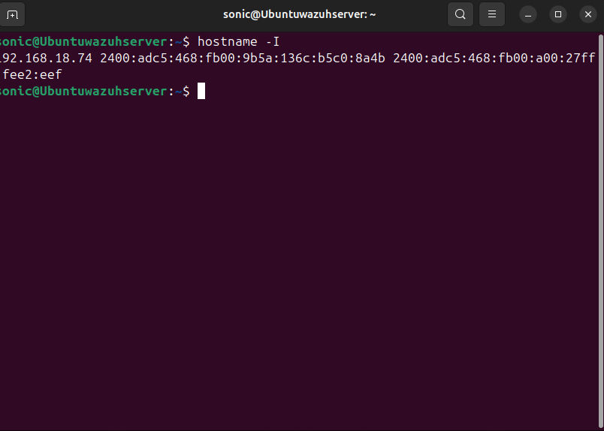

Here you can see my IP is 192.168.18.74 run this ip into your browser :
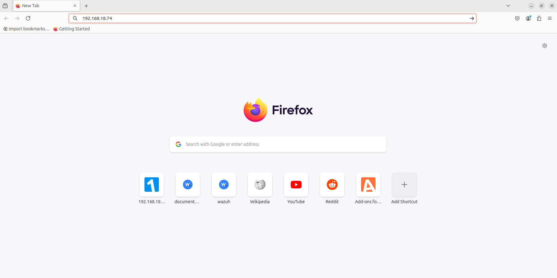

After that press enter and the following interface comes :
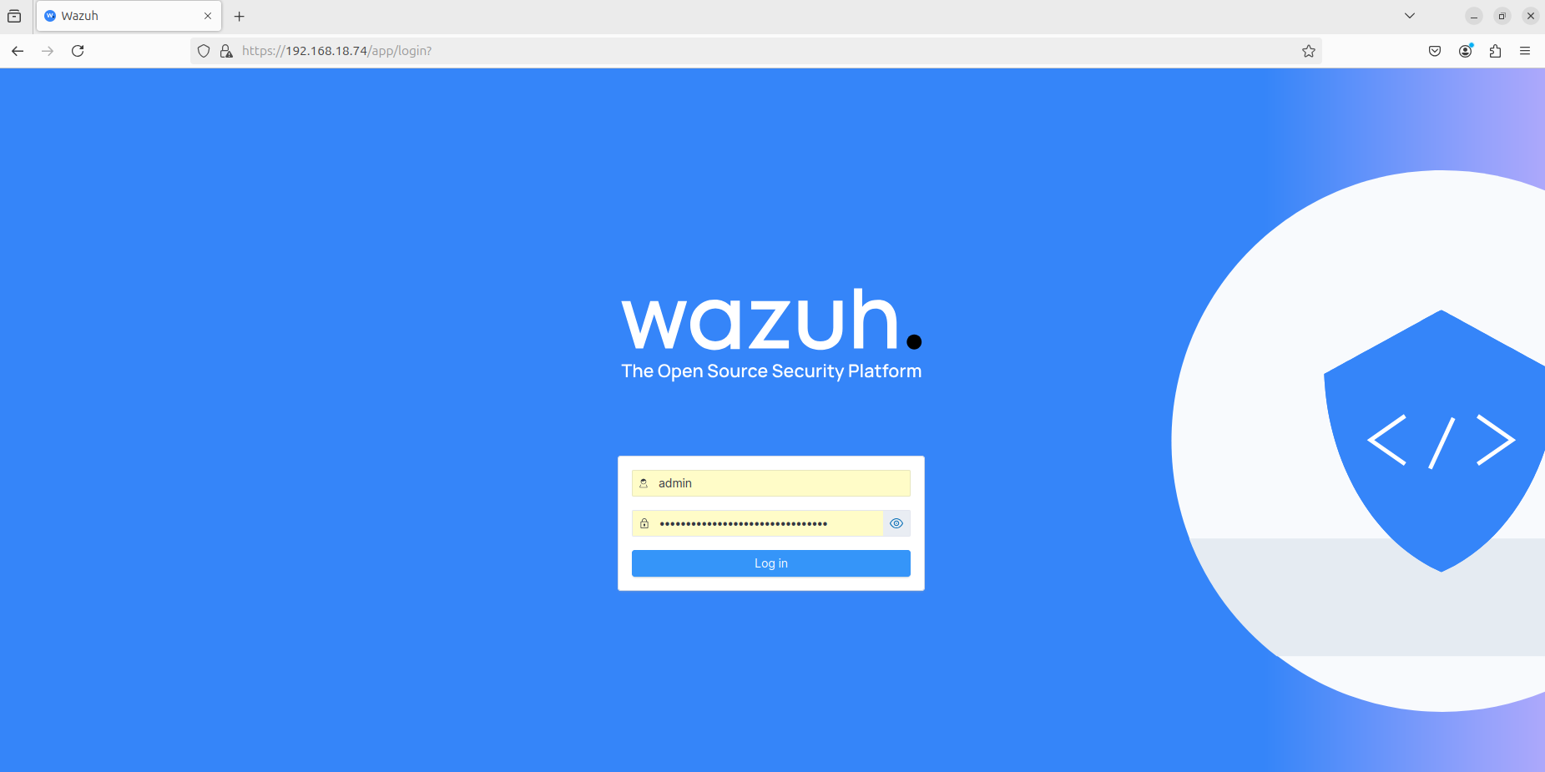

Enter the Username and Password and press enter :
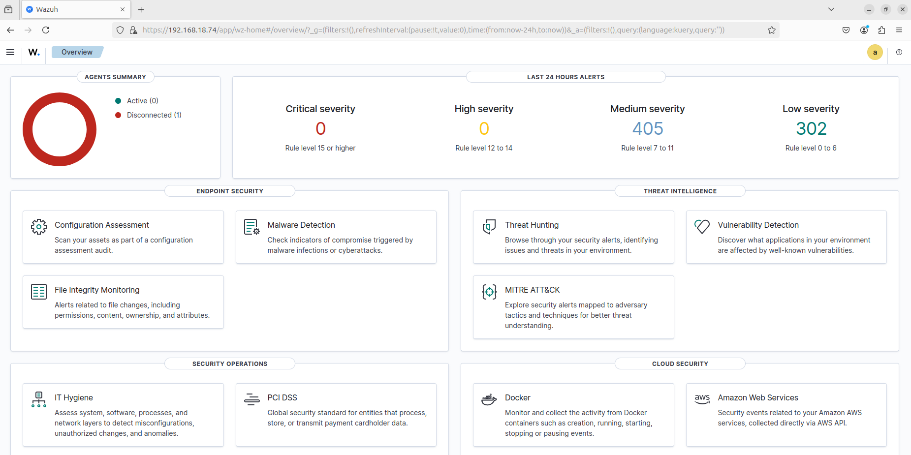

Because I already deployed an agent so it’s give me the information of my agent but Don’t worry I will completely explain you.

Here you can see the “Agents Summary”. On your dashboard the agent deploy message comes click on it.

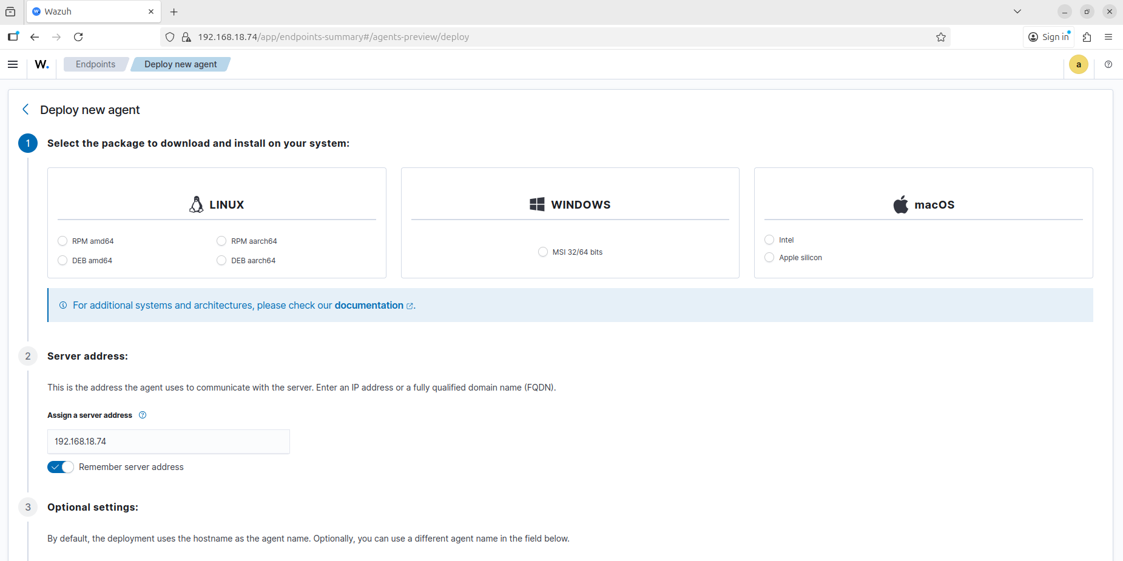

Know we are deploying our agent for windows so select windows then
Add the server IP on “Assign a server address” just as I put my address.

Recommendation :
Turn on Remember server address for future.

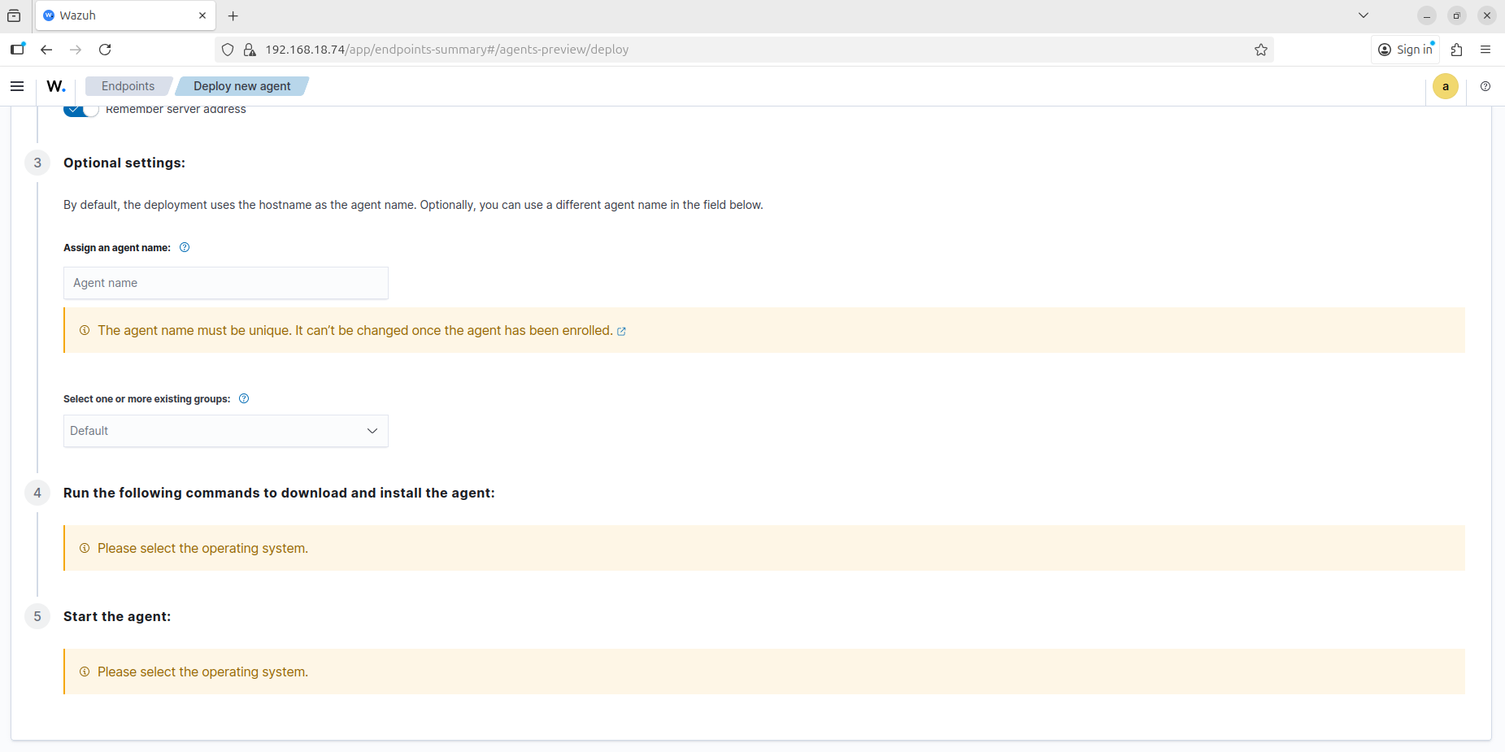

Add your agent name as Windows , linux and etc…
Select Group as a Default.

After giving all the information you can see that the command are comes.

Just copy the command and run in the windows machine powershell where you want to deploy your agent.

Node : First Run the Powershell as a Administrator then past the copy command on the powershell.

When the First process was completed then Run the following command to start your agent :
Command :

NET START Wazuh

After Running this command your agent sends information to the manager.

Know go into your Machine where your server is installed copy your host Address and past in browser search place.

Give your username and password -> press enter
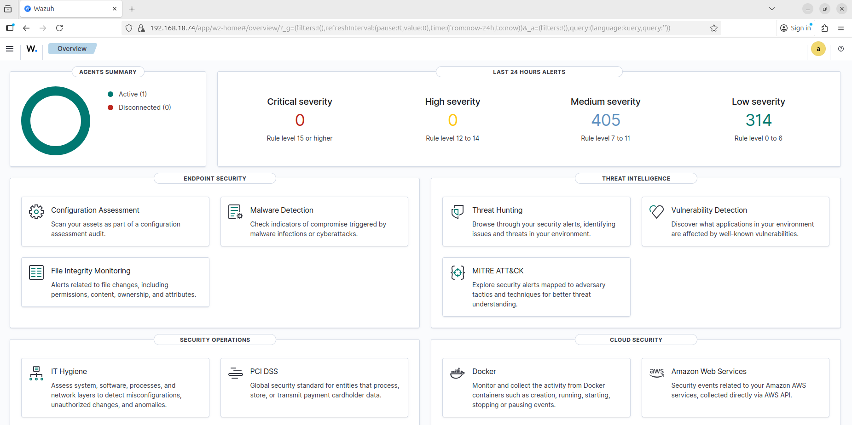
Click on Active
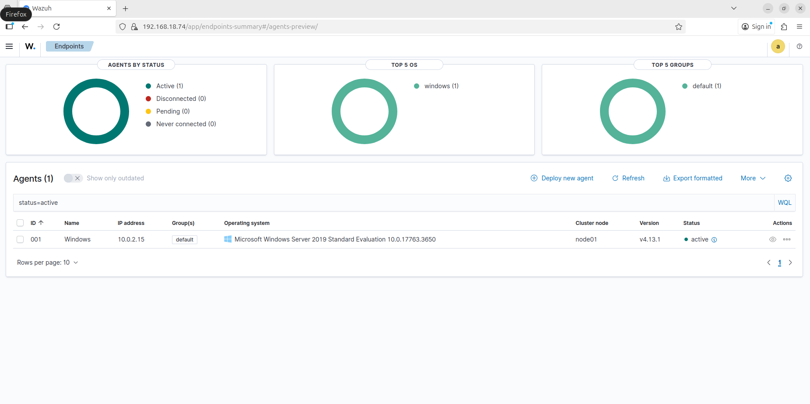
Here you can see your agent.

In future I will upload more information about wazuh in this repo

Know your server and agent is deployed successfully if there is any type of confusion then comment me. I will give you solution as soon as possible.

Best of Luck

